**Power Bi dashboard for Healthcare Analytics formula used :**

1. **Basics Measures:**
2. Out-of-Pocket = [Total Billing Amount] - [Total Insurance Cover]
3. Total Billing Amount = [Total Medication cost] + [Total Room Charges] +

 [Total Treatment Cost]

1. Total Insurance Cover =  SUM(visits[Insurance Coverage])
2. Total Medication cost =     SUM(visits[Medication Cost])
3. Total Patients = DISTINCTCOUNT(visits[Patient ID])
4. Total Room Charges = SUMX(  visits, visits[Room Charges(daily rate)] *

visits[Lenth of Stay])

1. Total Room Charges =   SUMX( visits, visits[Room Charges(daily rate)] *

  visits[Lenth of Stay]  )

1. **Average Measure**
2. Average Billing Amount per visit = DIVIDE( [Total Billing Amount], [Total Patients]
3. Average Insurance Coverage = AVERAGE(visits[Insurance Coverage])
4. Average length of Stay = AVERAGE(visits[Lenth of Stay])
5. Average Medication Cost = AVERAGE(visits[Medication Cost])
6. Average Out-of-Pocket = DIVIDE( [Out-of-Pocket],[Total Patients])
7. Average patient Satisfaction Score = AVERAGE(visits[Patient Satisfaction Score])
8. Average patient Satisfaction Score = AVERAGE(visits[Patient Satisfaction Score])
9. Average Treatment Cost = AVERAGE(visits[Treatment Cost])
10. **Other Formulas**
11. % Department = DIVIDE( [Total Billing Amount],CALCULATE( [Total Billing Amount], All(departments[Department])))
12. % Procedure = DIVIDE(  [Total Billing Amount],CALCULATE( [Total Billing Amount],  All(procedures[Procedure])))
13. Active Department = SELECTEDVALUE(departments[Department])
14. Blank Measures = 0
15. Average Room Charge = DIVIDE( [Total Room Charges],[Total Patients])

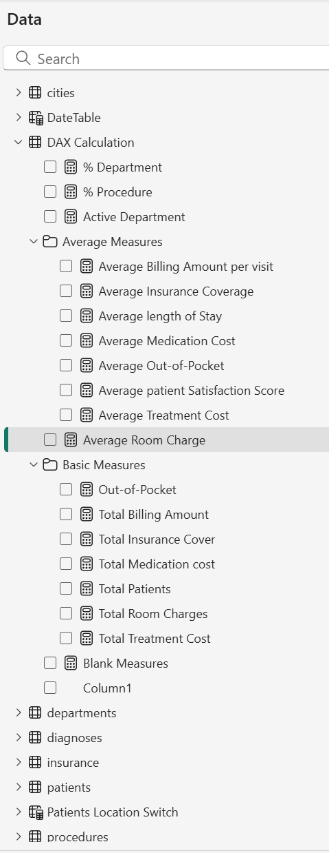

**Figure 1 Data Straucture**